Rotate your cluster credentials.

Step1: - We recommend that you check your credential lifetime before and after you perform a credential rotation so that you know the validity of your cluster root CA.

To check the credential lifetime for a single cluster, run the following command:

gcloud container clusters describe CLUSTER_NAME \  
    --region REGION_NAME \  
    --format "value(masterAuth.clusterCaCertificate)" \  
    | base64 --decode \  
    | openssl x509 -noout -dates

The output is similar to the following:

**notBefore=Mar 17 16:45:34 2023 GMT**

**notAfter=Mar 9 17:45:34 2053 GMT**

Step2: - Credential rotation involves the following steps:

1. **Start the rotation**: the control plane starts serving on a new IP address in addition to the original IP address. New credentials are issued to workloads and the control plane.
2. **Recreate nodes**: GKE recreates cluster nodes so that the nodes use the new IP address and credentials, respecting availability from maintenance windows and exclusions.
3. **Update API clients**: after starting the rotation, update any cluster API clients, such as development machines using kubectl, to communicate with the control plane using the new IP address.
4. **Complete the rotation**: the control plane stops serving traffic over the original IP address. Old credentials are revoked, including any existing static credentials for Kubernetes ServiceAccounts.

**Note: If you start a credential rotation, but don't complete it, GKE automatically completes the rotation after seven days.**

Step3: - Before starting the cluster credentials rotation, we should check the current control plane IP and information. This is important because, after completing the rotation, the control plane IP will be updated.  
  
Use the blow command to get the details.

kubectl cluster-info   
  
Example.

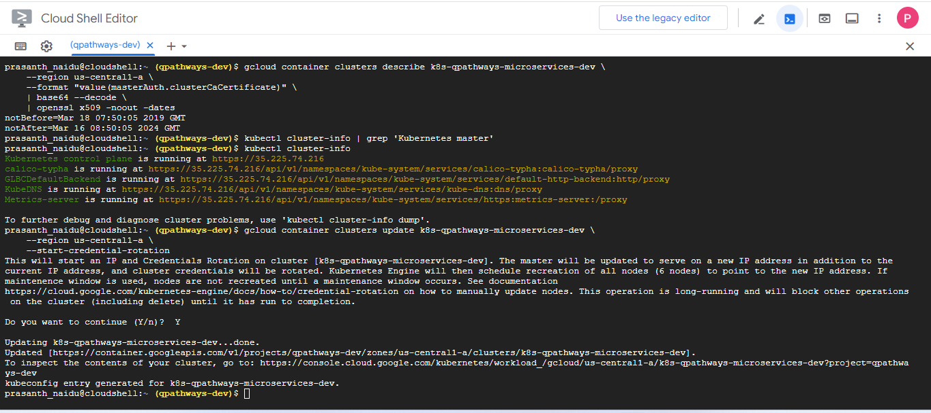

Step 4: - To start a credential rotation, run the following command:

gcloud container clusters update CLUSTER_NAME \  
    --region REGION_NAME \  
    --start-credential-rotation

This command creates new credentials, issues these credentials to the control plane, and configures the control plane to serve on two IP addresses: the original IP address and a new IP address.

#### This command causes brief downtime for the cluster API server.

#### Step5: - Check the progress of node pool recreation.

To monitor the rotation operation, run the following command:

gcloud container operations list

This command returns the operation ID of the node upgrade operation.  
  
To poll the operation, pass the operation ID to the following command:  
  
gcloud container operations wait operation ID

Node pools are recreated one-by-one, and each has its own operation. If you have multiple node pools, use these instructions to poll each operation.  
  
Step  
  
  
  
  
  
  
  
  
  
https://cloud.google.com/kubernetes-engine/docs/how-to/credential-rotation